

A Project Report On

NFT Quorum

(NFTs Auction Platform)

**Submitted By:** -

**Group - 16**

**Priya Shandilya(A45304821015)**

**Anas Faridi(A45304821019)**

**Ankur Deepak(A45304821020)**

**Ayush Raj(A45304821021)**

**Bachelor’s in computer application**

**Amity Institute of Information Technology**

**Academic Year:**

2021-2024

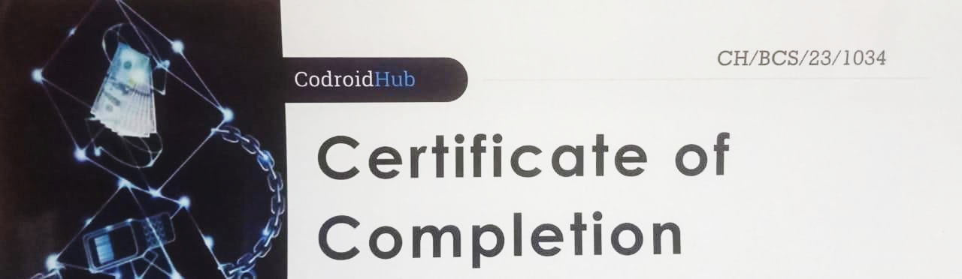

This is to certify that this project entitled “NFT’s Auction” submitted in partial fulfilment of the degree of BACHELOR IN COMPUTER APPLICATION (BCA) to Amity Institute of Information Technology, Amity University Patna done by Priya Shandilya(A45304821015), Anas Faridi(A45304821019),Ayush Raj(A45304821020) and Ankur Deepak(A45304821021),is an authentic work carried out by him/her under the guidance of Niraj Sir. The matter embodied in this project work has not been submitted earlier for award of any degree or diploma to the best of my knowledge and belief.

**Signature of the student**

**Name Enrollment no Signature**

Priya Shandilya A45304821015

Anas Faridi A45304821019

Ayush Raj A45304821020

Ankur Deepak A45304821021

**Signature of the Guide:** Date: ………………………..

Name :.Niraj Kumar Rai

Assistant Professor

AIIT,Amity University, Patna

# ACKNOWLEDGEMENT

This project being an enormous piece of work happens to be the outcome of time, hard work and patience of a multitude and was unfeasible to accomplish single handed. We feel and express our gratitude for **AMITY UNIVERSITY, PATNA** for giving us a strong foundation and infinite opportunities to harness our skills. This esteemed institute, under the proficient administration of Respected VC sir **Dr. TR Venkatesh** has been providing a nurturing environment to all its disciples for growing.

We took on this task with assurance coming from our HOD **Dr. Rashmi Shekhar** and an unremitting guidance and support of our mentor **Niraj Kumar Rai, Assistant Professor, AIIT,Amity University Patna.**Their direction and tutorial skills were the stimuli behind the completion of this project. We thank all the faculty members of **AIIT** for entrusting our potential.

Our parents being the source of inspiration and encouragement all the time deserve our indebtedness. We must mention our friends and family who stood there as a backbone. We are honor-bound to our seniors who offered help in every possible way.

# PREFACE

Non-Fungible Token (NFT) Auction is a digital marketplace where unique digital assets represented by NFTs are bought and sold. NFTs are special tokens used to prove ownership and authenticity of digital goods such as art, music, video, virtual real estate and in game items. It includes artists, collectors, and enthusiasts involved in the buying, selling and trading of certain digital assets, participating in NFT auctions. Competition has changed our view of property in the digital age, fostering a new era of creativity, innovation, and virtual possibilities. NFT auctions provide a glimpse into the future of digital property and the connection between art and blockchain technology

.

**INDEX**

1. **Summary**

**1.1** Introduction………………………………. ……….…7

**1.2** Specific problem in statement…………………..…….8

**1.3** Objective…………………………….…………….….8

**1.4** Scope of NFTs auction……………………………….9

**1.5** Stakeholders and their roles……………………….…10

**1.6** Existing solution of NFTs auction……………….…..11

**1.7** Specific people involved and their roles………...…...12

**1.8** Asset involve in NFTs auction…………….……..….13

**1.9** Transaction taking place in NFTs auction….………..14

**1.10** Steps in NFTs auction……………………….……...15

**1.11** Benefits of using blockchain in NFTs auction….…..16

**1.12** Legal systems in NFTs auction………………….….18

1. **Design principles……………………………………...…20**

**2.1** Design principle-1…………………………….……....20

**2.2** Design principle-2……………………………...……..21

**2.3** Design principles-3…………………………..…….....22

**2.4** Design principles-4……………………….…………..23

**2.5** Design principles-5…………………………..……….24

1. **Implementation** ……………………………………..…25

**3.1** How to deploy the smart contract ……………………25

**3.2** Admin initiates registration of bidders……………….26

**3.3** Admin begins the bidding process……………...…….26

**3.4** Bidders will start bidding……………………………..26

**3.5** Admin ends the bidding process……………….……..26

**3.6** Declaration of winner’s name…………………...……26

**3.7** Screenshot………………………………………….26

1. **Testing**………………………………………..……….30

**4.1** Testing technique……………………………..…...30

**4.1.1** Unit Testing………………………………...30

**4.1.2** Integration Testing………………………….30

**4.2** Testing case design and report………………….…31

**4.2.1**Unit Testing Report…………………...……..31

**4.2.2**Integration Testing Report…………………..32

1. **Resources and limitations**…………………..………..33

**5.1** Resources…………………………………………..33

**5.2** Limitations…………………………………………34

1. **Conclusion**……………………………………………..35
2. **Reference**s…………………………………………..…36
3. **Annexture**………………………………….…………..37

**1. SUMMARY**

**1.1 Introduction**

In this increasingly digital world where art, content and virtual experiences havebecome an integral part of our lives, an incredible phenomenon has emerged: the NonFungible Token (NFTs) Auction. NFTs have revolutionized our understanding of ownership in the digital age by providing a unique and secure way to represent a digital asset.  
  
Unlike traditional cryptocurrencies, NFTs are indivisible and have unique properties that make them the perfect medium to represent unique digital creations. Creators, artists, and collectors come together to explore a whole new world of property, creativity, and value through NFTs auctions.  
  
This competition is a gateway to the exciting field where art, innovation and technology intersect.

Here, digital artists express their ideas and present their great work in NFTs format, while collectors and enthusiasts can acquire and observe these digital talents.  
  
In addition to the art world, NFTs auctions were held in many areas from virtual real estate to games, from music to virtual identities. Each competition has become a celebration of innovation and vision, and the value of these NFTs goes far beyond value for money.

In the introduction to NFTs auctions, we invite you to embark on a journey of discovery and discovery. Witness the combination of beauty and blockchain technology paving the way for a future where digital property will take center stage.  
Get ready to be impressed by the creativity of the creators, be captivated by their unique love of digital art, and be inspired by the endless possibilities NFTs bring to the world. Welcome to NFTs Auctions, where the digital frontier of ownership and creativity awaits you.

**1.2 Specific problem in statement**

Non-Fungible Tokens, are a type of digital asset that represent ownership or proof of authenticity of a unique item or piece of content using blockchain technology. Unlike cryptocurrencies such as Bitcoin or Ethereum, which are fungible and can be exchanged on a one-to-one basis, NFTs are unique and cannot be exchanged on a like-for-like basis.

Security is a critical concern in NFTs auctions due to the digital nature of the assets and the potential for fraudulent activities.some major problems related to security in NFTs auctions are Phishing and Scams, Smart Contract Vulnerabilities etc.

So we'll create a digital art auction platform where artists can mint their unique digital artworks as NFTs and auction them to interested buyers. The platform will be built on a blockchain network that supports NFTs, such as Ethereum.

**1.3 Objective**

**Purpose of NFTs Auction:**

The main purpose of NFTs Auction is to facilitate the buying and selling of digital assets represented by NonFungible Tokens (NFTs). NFTs are used to prove ownership and authenticity of these digital assets, including digital art, music, video, virtual real estate, ingame items, and more.

By creating the NFTs digital marketplace, the aim is to provide a platform where artists, collectors and enthusiasts can participate in the trading and exchange of unique digital goods.  
  
**NFTs Auction aims to achieve several main goals**:  
  
Support Creators: NFTs Auctions supports artists and creators by giving them the opportunity to directly promote their unique work and connect with an international audience.  
  
Digital Assets on Display: Auctions showcase a variety of digital assets, allowing buyers and collectors to search for and discover unique digital content

Create value: NFTs auctions create the value of digital assets in the NFTs ecosystem through bidding and trading, reflecting demand and interest in digital assets and content.  
  
Creating a secondary market: NFTs auctions potentially provide additional benefits to creators and collectors by facilitating a secondary market for NFTs, enabling owners to resell their digital assets to other interested parties.

**1.4 Scope of NFTs Auction**

* Digital Art: NFTs auctions play an important role in the digital art world, enabling artists to create and sell their digital art, create ownership and proof.
* Music and Entertainment: Music, content creators and advertising companies can use NFTs auctions to tokenize and sell music, movies, and other entertainment items.
* Virtual Real Estate: Virtual Worlds and Virtual Worlds use NFTs auctions to buy, sell and barter virtual property or land, creating new opportunities for virtual owners.
* Gaming: NFTs have become popular in the gaming industry, where unique in-game items, characters, and equipment can be auctioned off and traded.
* Collection: NFTs auctions are an important part of the digital collectibles marketplace, where unique and rare items are tokenized and made available to collectors.
* Intellectual property and licensing: NFTs can represent ownership or licensing rights to digital content, enabling creators to protect and monetize their intellectual property. As the technology and adoption of
* NFTs continues, NFTs auctions will expand to include new practical and commercial applications and will have a profound impact on our thinking about ownership, creativity, and value in the digital age.

**1.5 Stakeholders and their roles**

In an NFTs sell off, a few partners play basic parts in encouraging and taking an interest within the sell off handle. Each partner contributes to the victory and usefulness of the sell off environment. Here are the key partners and their parts in an NFTs auction:

* Creators/Artists: Makers or craftsmen are the people who deliver the computerized resources that are represented as NFTs within the sell off. They mint their one of a kind works of art, music, recordings, or other advanced substance as NFTs, permitting them to grandstand and monetize their manifestations on the platform.
* Sellers: Venders are the people or substances who own the NFTs and wish to sell them within the sell off. They can be the initial makers or collectors who procured the NFTs through past transactions.
* Buyers: Buyers are members inquisitive about procuring NFTs through the sell off. They put offers on the NFTs they wish to buy and compete to be the most noteworthy bidder by the conclusion of the auction.
* NFTs Marketplace/Platform: The NFTs commercial center or stage serves as the computerized foundation where the sell off takes put. It gives the essential innovation, smart contracts, and client interface for members to list, offered, and exchange NFTs.
* Smart Contracts: Keen contracts are self-executing contracts that mechanize different forms within the sell off, such as offering, deciding the winning offered, and exchanging possession. They guarantee straightforward and tamper-resistant execution of sell off rules and terms.
* Auctioneer (Discretionary): In a few NFTs barters, an salesperson may play a part in managing the sell off prepare, overseeing offering, and encouraging communication between members. In decentralized stages, this part may be satisfied by the savvy contract.
* Secondary Advertise Stages (Discretionary): After the starting sell off, NFTs holders may select to offer their NFTs on auxiliary advertise stages. These stages encourage the exchanging of NFTs between members after the essential sell off has concluded.
* Collectors and Debides: Collectors and debides are people energetic around NFTs and advanced collectibles. They effectively take an interest in barters to secure special and uncommon NFTs that adjust with their interface and preferences.
* Developers and Specialized Groups: The improvement and specialized groups are capable for building and keeping up the NFTs sell off stage, guaranteeing its security, usefulness, and convenience for all participants.
* Regulators and Legitimate Substances: Controllers and lawful substances screen the NFTs sell off space to guarantee compliance with important laws and directions, defending the rights of members and tending to potential issues related to extortion or illicit activities.
* Community and Administration Members (Discretionary): A few NFTs stages include community administration models, permitting members to have a say in stage choices and approaches, advancing straightforwardness and inclusivity.

Each partner plays a crucial part in contributing to the NFTs sell off biological system, cultivating inventiveness, development, and esteem within the advanced resource advertise. Collaboration and participation among these partners contribute to the development and supportability of the NFTs sell off space.

**1.6 Existing solution of NFTs auction**

* OpenSea: OpenSea is one of the biggest and most prevalent NFTs marketplaces. It permits clients to form, purchase, offer, and sell off NFTs speaking to a assortment of computerized resources, counting work of art, collectibles, virtual real estate, and more.
* Rarible: Rarible could be a no-transaction NFTs that permits makers to print and sell off their computerized resources straightforwardly on the stage. It runs on the Ethereum blockchain and is known for its administration structure related with stage participants.
* Foundation: The Establishment could be a imaginative stage that points to empower craftsmen to grandstand and offer their digital artworks in NFTs format.
* It points to bolster engineers by giving the environment for art-driven NFTs auctions.
* SuperRare: SuperRare could be a blockchain-based art platform centered on uncommon computerized craftsmanship. By giving collectors elite things, it permits specialists to sign and sell off constrained version artworks.
* Nifty Door: Clever Door could be a stage for elite NFTs rebates and barters from popular specialists, artists, and celebrities. It highlights a curated choice of tall profile NFTs auctions.
* CryptoKitties: Initially well known as a advanced collectibles amusement, CryptoKitties moreover highlights a commercial center where clients can purchase, offer and offer special advanced cat NFTs.

**1.7 Specific people involved and their roles**

* Creators/Artists: Creators and artists are the individuals or entities who produce and tokenize the digital assets that are auctioned as NFTs.
* Buyers/Collectors: Buyers or collectors are individuals or institutions interested in acquiring NFTs through auctions. They participate in the bidding process and contribute to the overall demand and value of NFTs.
* Auction Platforms: These are the online platforms or marketplaces that facilitate NFTs auctions. They provide the infrastructure and technology for creators to list their NFTs, buyers to place bids, and the auction process to take place.
* Auction Curators: Some platforms or projects employ auction curators or experts who curate and select the NFTs that are eligible for auction.
* Developers and Auditors: Developers and smart contract auditors play a crucial role in creating and reviewing the smart contracts used in NFTs auctions.

They help ensure the security and functionality of the auction platforms, identify vulnerabilities, and mitigate risks associated with the smart contracts powering the auctions.

**1.8 Assets involve in NFTs auction**

In an NFTs auction, a wide range of digital assets can be involved, representing various forms of digital content. These assets are unique and indivisible, each represented by its own Non-Fungible Token (NFTs). Here are some common types of assets that are often involved in NFTs auctions:

* Digital Artwork: Digital artists can tokenize their artwork as NFTs, making them one-of-a-kind digital collectibles. These artworks can be paintings, illustrations, animations, and other digital creations.
* Music and Audio: Musicians and artists can tokenize their music tracks, albums, and audio content as NFTs, providing exclusive ownership and access to their work.
* Videos and Films: Content creators, filmmakers, and video artists can tokenize their videos, short films, and other visual media as NFTs, creating unique ownership and provenance for their creations.
* Virtual Real Estate: In virtual worlds and metaverses, users can buy, sell, and auction virtual real estate or virtual land as NFTs.
* Collectibles: Digital collectibles, also known as "crypto-collectibles," can include unique characters, avatars, trading cards, and other items that are tokenized and traded in NFTs auctions.
* Virtual Items in Gaming: NFTs are used in gaming to represent unique in-game items, skins, weapons, and accessories, which players can buy, sell, and trade.
* Domain Names: Digital domain names can be tokenized as NFTs, allowing users to buy, sell, and auction virtual properties that represent web addresses.
* Virtual Identities and Avatars: NFTs can also represent virtual identities and avatars that users can use in virtual worlds or social platforms.
* Digital Collectibles from Brands and Celebrities: Brands, celebrities, and influencers can create branded NFTs or digital collectibles for their fans to collect and trade.
* Intellectual Property and Licensing: NFTs can represent ownership or licensing rights for digital content, allowing creators to protect and monetize their intellectual property.

It's important to note that the NFTs space is continuously evolving, and new types of digital assets may emerge over time. NFTs auctions offer a versatile and dynamic marketplace for various digital creators and collectors to engage in buying, selling, and trading these exclusive digital assets.

**1.9 Transaction taking place in NFTs auction**

In an NFTs auction, a few exchanges take put as members lock in in buying, offering, and exchanging Non-Fungible Tokens (NFTs) speaking to one of a kind advanced resources. Here are the key exchanges that happen amid an NFTs auction:

* Bidding: Interested buyers put offers on the NFTs they wish to secure. Offering includes advertising an sum they are willing to pay for the NFTs. Members can raise their offers until the auction's end.
* Accepting Offers: The sell off stage or savvy contract records and acknowledges offers from members. The current most noteworthy offered is freely shown for all members to see.
* Outbidding: In the event that a participant's offered is outperformed by another bidder, they have the alternative to put a unused, higher offered (outbid) to recover the driving position within the auction.
* Auction Expenses: A few sell off stages charge expenses to members, counting posting expenses for venders and offering expenses for buyers. These expenses may shift based on the platform's policies.
* Payment and Settlement: Once the sell off concludes, the winning bidder is required to create the installment for the NFTs. Installments are as a rule made in cryptocurrency, such as Ether for Ethereum-based NFTs. The stage or shrewd contract guarantees the settlement of the payment.
* Transfer of Possession: Upon effective installment, proprietorship of the NFTs and the related advanced resource is exchanged from the dealer to the winning bidder. This exchange is recorded on the blockchain, giving an permanent record of ownership.

It's vital to note that NFTs barters can be conducted on different stages, and the subtle elements and mechanics may shift depending on the platform's highlights and functionalities. Furthermore, each sell off may have its claim terms and conditions, counting sell off term, save cost, and other variables that affect the generally exchange handle. The utilize of blockchain innovation guarantees straightforwardness, security, and provable proprietorship all through the complete sell off prepare.

**1.10 Steps in NFTs auction**

The steps of an NFTs auction usually involve various processes that facilitate the buying and selling of non-fidelity tokens (NFTs) representing certain digital assets. The main steps performed during an NFTs auction are:

1. Issuing: The creator or seller of digital assets issues the NFTs, which involves creating tokens that represent digital assets. This step provides identity and ownership to the NFTs on the blockchain.
2. Listing: A seller lists NFTs for bidding on an NFTs market or platform. They show the starting bid, the special price (choose the lowest price), the bidding time, and other details of the NFTs.
3. Bidding: Buyers are willing to bid for the NFTs they wish to purchase. The bidding process involves giving them the amount they are willing to pay for the NFTs. Participants can increase their bids until the end of the competition.
4. Proxy Bidding (optional): Some NFTs auction platforms use proxy bidding, where participants set a maximum bid and the platform automatically raises the bid as the auction progresses until the maximum bid is reached.
5. Auction Period: NFTs auctions have an auction period. At the end of the bidding period, the highest bid becomes the winning bid.
6. Overbid: If a higher bidder is placed by another bidder, a bidder has the option to overbid to take the lead in the auction.
7. Auction Fees: Some auctions charge participants fees, including listing fees for sellers and auction fees for buyers. These fees may vary according to the rules of the platform.
8. Winning Bid: At the end of the auction, the highest bid becomes the winning bid. The bidders will be the new owners of the NFTs.
9. Payment: The buyer must make the NFTs payment after receiving the offer. Payments are usually made to Ethereum-based NFTs in cryptocurrencies such as ether. The platform or smart contract enables the settlement of payments.
10. Transfer of Ownership: After successful payment, ownership of the NFTs and related assets will be transferred from the seller to the winning bidder. This transaction is recorded on the blockchain and provides an immutable record of ownership.
11. Secondary market (optional): After the first auction, NFTs holders have the option to sell their NFTs on the secondary market. These secondary transactions involve the transfer of the name from the seller to the buyer at a negotiated price.

**1.11 Benefits of using blockchain in NFTs auction**

* Unchanging nature and Beginning: Blockchain gives an unchanging and straightforward record that records the possession history of each NFTs. This gives confirmation of computerized resources, making a genuine sense of proprietorship from the maker to the current proprietor. Members can increment trade certainty by confirming the genuineness and history of NFTs.
* Secure Exchanges: Blockchain-based NFTs barters use cryptographic conventions to supply secure and tamper-proof exchanges. This guarantees that each NFTs is special and cannot be replicated or copied, lessening the chance of extortion, extortion, or twofold spending.
* Decentralized and Disposing of Mediators: Blockchain empowers decentralized NFTs barters, killing the require for middle people such as sell off houses or brokers. Costs can be diminished and proficiency expanded by permitting coordinate competition between buyers and sellers.
* Global Reach: NFTs barters on the blockchain are available to a global audience. Anybody with a web association can take an interest in bidding and exchanging NFTs, advancing integration and differing qualities within the marketplace.
* Property Administration: NFTs on the blockchain give genuine property to buyers.
* Unlike conventional computerized resources, which are regularly controlled by a central substance, NFTs holders have full control over their computerized assets.
* Smart contracts and mechanization: Savvy contracts are stand-alone contracts that oversee the terms and conditions of the sell off. They diminish the require for manual mediation by encouraging a consistent and robotized prepare, counting tenders, compromises, and title changes.
* Interoperability: NFTs on blockchains are interoperable, meaning they can be utilized over numerous stages and applications that back the same blockchain show. This gives more adaptability in how NFTs are utilized and exchanged in
* the ecosystem.
* Copyright and Craftsman Emolument: Shrewd contracts can be outlined to incorporate legitimate systems, permitting craftsmen to get a rate of future deals when their NFTs is sold on auxiliary markets. This guarantees that makers are routinely paid based on the ubiquity and esteem of their work.
* Transparency and community administration: A few blockchain-based NFTs stages incorporate community administration structures that permit members to have a say within the advancement and rules of the stage. This advances straightforwardness and solidarity within the decision-making process.

Overall, the utilize of blockchain in NFTs barters has changed the way computerized resources are bought, sold, and owned.

It gives a secure, straightforward, and autonomous environment that empowers producers, collectors, and exhibitors to take part in a modern time of computerized possession and inventiveness.

**1.12 Legal systems in NFTs auction**

The lawful frameworks and controls appropriate to NFTs barters can change depending on the ward in which the sell off takes put and the parties included. NFTs barters include a few legitimate perspectives that must be considered to guarantee compliance and ensure the rights of members. Here are a few lawful contemplations in NFTs auctions:

* Intellectual Property Rights: NFTs barters frequently include the deal of computerized works of art, music, recordings, and other imaginative substances. Guaranteeing that the vender has the fundamental mental property rights to offer the NFTs is fundamental to maintaining a strategic distance from copyright encroachment issues.
* Contractual Understandings: NFTs barters regularly include legally binding assertions between the stage, dealer, and buyer. Clear and nitty gritty terms and conditions ought to be set up to outline the rights and duties of each party included within the auction.
* Consumer Assurance Laws: Depending on the locale, buyer assurance laws may apply to NFTs barters, particularly on the off chance that the buyers are considered buyers. Stages ought to follow these laws to secure the rights of buyers and guarantee reasonable exchange practices.
* AML and KYC Compliance: Anti-Money Washing (AML) and Know Your Client (KYC) controls may apply to NFTs barters, particularly when noteworthy exchanges are included. Stages may have to be execute measures to confirm the character of members and screen suspicious activities.
* Taxation: The deal of NFTs may have assess suggestions, counting capital picks up charges, depending on the assess laws of the important wards. Venders and buyers ought to be mindful of their charge commitments related to NFTs transactions.
* Privacy and Information Assurance: Stages dealing with individual information of members must comply with
* security and information assurance laws to protect the protection and security of client information.
* Securities Laws: In a few cases, NFTs may be classified as securities, particularly in case they speak to proprietorship in a company or speculation conspire. Compliance with securities laws may be fundamental to dodge administrative issues.
* Smart Contract Inspecting: Stages utilizing shrewd contracts to encourage NFTs barters ought to guarantee that the contracts are completely inspected for security and exactness to anticipate vulnerabilities and potential lawful disputes.
* Jurisdictional Contrasts: NFTs barters are available all inclusive, but lawful necessities and controls can vary essentially from one nation to another. Stages ought to consider the laws of the wards where their members are located.

It's vital for NFTs stages, makers, buyers, and dealers to look for legitimate exhortation and guarantee compliance with important laws and directions to dodge potential lawful pitfalls and ensure the rights of all parties included. The legitimate scene encompassing NFTs and blockchain innovation is ceaselessly advancing, so remaining educated approximately changes in directions is pivotal.

**2. Design principles**

**2.1 Design principle – 1**

1.Following are some of the data types that we are going to use in our smart contract: -

• address payable public beneficiary.

• unit public auctionEndTime.

• address public highestBidder.

• uint public highestBid.

• mapping (address => uint) pendingReturns.

• bool ended.

2.Following are some of the functions that we are going to use in our smart contract

• function bid ()

• function withdraw ()

• function auctionEnd ()

3.Following are the state variables that we are going to use in our smart contract

address payable public beneficiary.

uint public auctionEndTime.

address public highestBidder.

uint public highestBid.

2.2 Design principle – 2 (USE Case Diagram)

Bidder

Admin

**2.3 Design principles - 3**

1. **Data assets to track**

* The number of bids given by the bidders to the NFTs present in the auction.

1. **Peer participants**

* Here the only peer participant will be the give Bid function.

1. **Role of the peer participant**

* If the bidder bids for a particular NFTs then the give Bid function increases the number of bids received by that candidate by 1.

1. **Rules to be verified and validated.**

* Following are some of the rules that needs to be verified before the execution of the give Bid () function:-
* We must check whether the bidding has started or not.
* We must check whether the bidder is the possessor(owner) or not because the owner isn’t allowed to bid.
* We must check whether the bidder has registered or not.
* We must check whether the bidder has already bid or not.
* We must check whether the candidate is registered or not.

1. **Transactions to be recorded in the digital ledger –**

* Give Bid ()

**2.4 Design principle – 4 (UML)**

|  |
| --- |
| Auction for NFTs |
| contract NFTs Auction |
| function bid ()  The number of bids given by the bidders to the NFTs present in the auction. |
| Here the only peer participant will be the Bid function |
| If the bidder bids for a particular NFTs then the giveBid function increases the number of bids received by that candidate by 1 |
| function auctionEnd ()  Following are some of the rules that needs to be verified before the execution of the giveBid () function: - |
| We must check whether the bidding has started or not. |
| We must check whether the bidder is the possesor(owner) or not because owner isn’t allowed to bid. |
| We must check whether the bidder has registered or not. |
| We must check that whether the bidder has already bided or not. |
| We must check that whether the candidate is registered or not. |
| function auctionEnd ()  Transactions to be recorded in the digital ledger – giveBid () |

**2.5 Design principle – 5**

|  |
| --- |
| **NFTs Auction** |
| + bidders: Person []  + bids: Bid []  + winner: address  + highest bidder_till_now: Person |
| + auctionStart ()  + auctionEnd ()  + auctionCancel ()  + registerBidder ()  + placeBid (Person, TokenID)  + withdrawBid (Person)  - transfer Token ToWinner ()  - returnAmountToBidders ()  + getWinner () |

**3. IMPLEMENTATION**

**3.1 How to deploy the smart contract?**

First, we write our smart contract, we click the "Solidity Compiler" tab on the left-hand side to compile your smart contract code, then from the "Deploy & Run Transactions" tab on the right-hand side, we choose an appropriate environment, then we fill in the constructor parameters if our contract, as in our case ` _event Name` is the parameter to be filled. Finally, we click the "Deploy" button to deploy our smart contract.

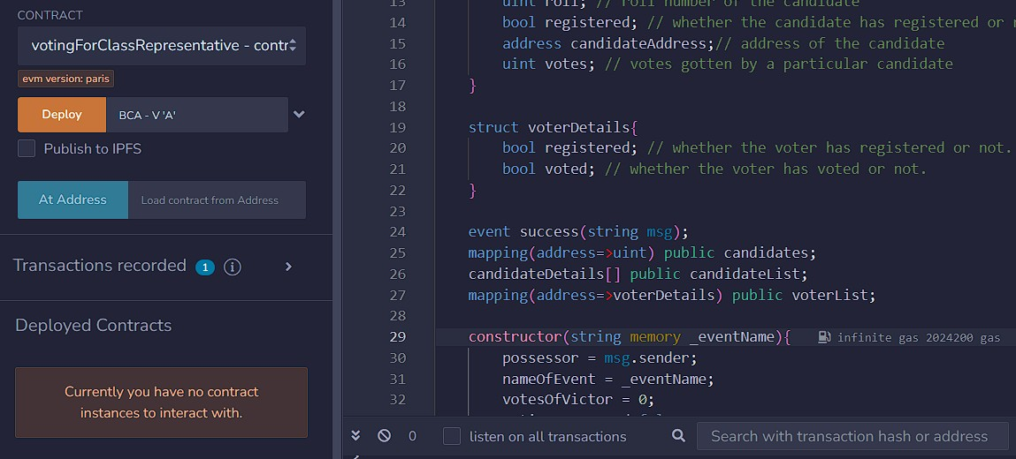

**3.2 Admin initiates registration of bidders**

Now, before the start of the bidding process, admin will register the bidders and candidates. For candidate registration, name, roll number and address of the candidate is required whereas for the registration of bidders, only the address of the bidders is more than enough.

**3.3 Admin begins the bidding process.**

Now, the admin will start the bidding process during which the bidders will bid for their preferred candidate with the help of their addresses. One important thing to note here is that the bidders can start bidding only after the bidding process has been initiated by the admin. If any bid tries to bid before the initiation, then he/she will not be able to bid. Another important thing here is.

that only the admin can initiate the bidding process and not anyone else.

**3.4 Bidders will cast their bids now.**

Bidders will now switch to their respective accounts to cast off their bids to their preferred candidates. Here, the important thing to note is that the bidders can cast their bids only once, after which if they try to cast another bid, they will not be able to do so.

**3.5 Admin ends the bidding process.**

Now, the admin will end the bidding process to find out the winner of the election. One important thing to note here is that the bidders can’t bid only after the bidding process has been terminated by the admin. If any bid tries to bid after the termination, then he/she will not be.

able to bid. Another important thing here is that only the admin can terminate the bidding process and not anyone else.

**3.6 Declaration of winner’s name**

Admin can now declare the name of the winner to finally determine who will be the class representative of the class. Note that only the owner has the right to declare the winner’s name.

**3.7 Screenshots**

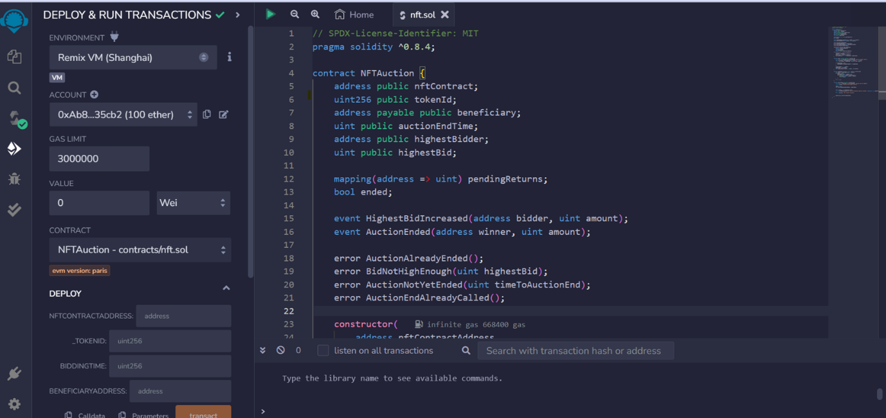

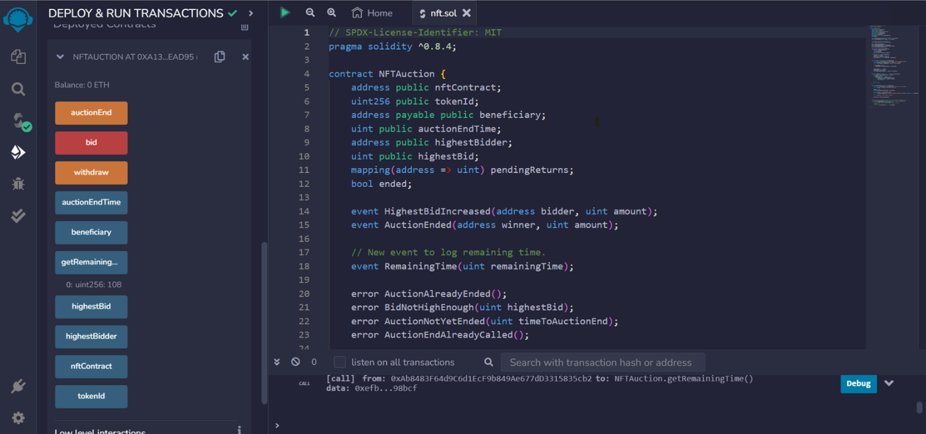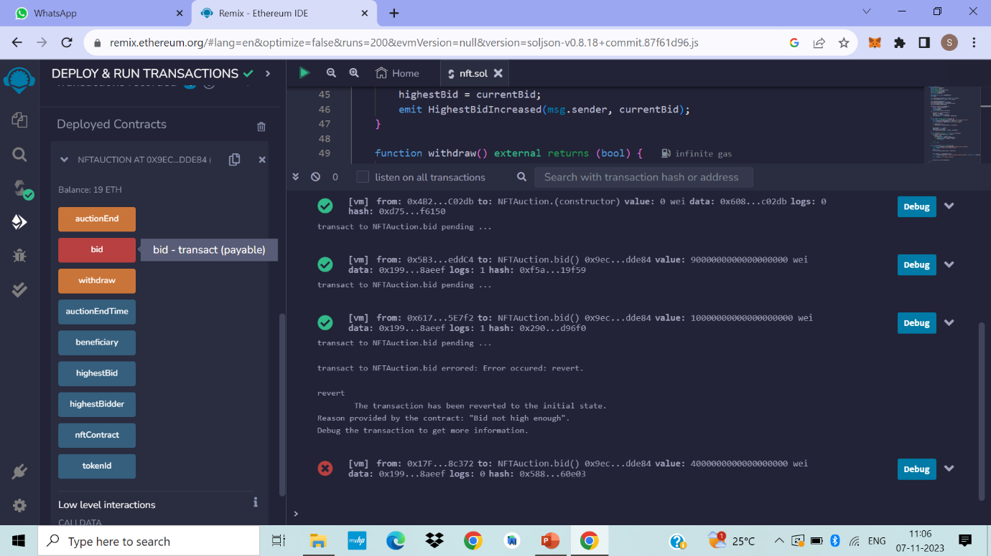

**4. TESTING**

**4.1 Testing technique**

Testing is a crucial software development practice that involves systematically evaluating and verifying a piece of software to ensure that it meets its intended requirements and functions correctly. The primary purpose of testing is to identify and fix defects or issues in the software, ultimately improving its quality, reliability, and performance. It is a part of project design.

Without testing, a project isn’t considered complete because testing provides us with the real functioning picture of our development.

We performed the following testing methods in our project -

**4.1.1 Unit Testing**

Unit testing is a software testing technique that focuses on evaluating individual units or components of a software application in isolation. A "unit" typically refers to the smallest testable part of a program, such as a function, method, or class.

How do unit tests work?

Unit tests work by isolating and systematically evaluating individual units or components of software, such as functions, methods, or classes, in isolation. Each unit test focuses on a specific aspect of the unit, providing predefined inputs and checking whether the expected outputs match the actual results. By automating these tests and running them frequently, developers can quickly identify and fix issues, ensure the unit's correct behavior, and maintain the integrity of the software.

**4.1.2 Integration Testing**

Integration testing is a software testing method that assesses the interactions and interfaces between different components or modules of a software application to ensure that they work.

together as intended. It aims to detect issues that may arise when these components are combined and integrated into a complete system.

How do integration tests work?

Integration tests work by evaluating the interactions and interfaces between multiple components or modules within a software application to confirm their seamless collaboration. These tests examine the flow of data and control as components are combined, aiming to uncover issues.

related to communication, data compatibility, and interface correctness.

Testing case design and report

**4.2 Test case design**

Test cases are those specified areas where we check whether our system is working perfectly or not. For our project, the following are some of the test areas on which we performed some tests during the project.

**4.2.1 Unit testing Report:**

|  |  |  |  |  |
| --- | --- | --- | --- | --- |
| **Test case ID** | **Test Case Description** | **Expected Output** | **Actual Output** | **Pass/Fail** |
| TC1 | Check if the Auction is active. | True | True | Pass |
| TC2 | Check if the Auction is not active. | False | False | Pass |
| TC3 | Check if admin can bid. | True | True | Pass |
| TC4 | Check if one bidder can bid multiple time. | True | True | Pass |
| TC5 | Check if withdrawal request can be initiated. | No error,  withdrawal request is initiated. | No error,  withdrawal request is initiated. | Pass |
| TC6 | Check if withdrawal request can be initiated. | Revert error,  Withdrawal request is initiated. | Revert error,  Withdrawal request is initiated. | Pass |
| TC7 | Check if, withdrawal.  Request can be revoked. | No error, withdrawal request is revoked | No error, withdrawal request is revoked | Pass |

**4.2.2 Integration Testing Report:**

|  |  |  |  |  |
| --- | --- | --- | --- | --- |
| **Test case ID** | **Test Case Description** | **Expected Output** | **Actual Output** | **Pass/Fail** |
| TC8 | Check if the bidder can bid | True | True | Pass |
| TC10 | Check if withdrawal can execute by the beneficiary | True | True | Pass |
| TC11 | Check if withdrawal cannot be executed when the auction is active. | Withdrawal is not allowed during the  active auction. | Withdrawal is not allowed during the  active auction | Pass |
| TC12 | Check after withdrawal the balance is managed | True | True | Pass |
| TC13 | Check if withdrawal request can be initiated by only.  Admin. | No error,  withdrawal request is initiated by admin only. | No error,  withdrawal request is initiated by admin only. | Pass |

**5.RESOURCES AND LIMITATIONS**

**5.1 RESOURCES**

Designing a voting system for a class representative election using blockchain technology requires careful planning, as it involves both traditional project management considerations and blockchain-specific elements. Below are the key resources and steps we'll need to consider:

1. **Project management resources -**

* Project Manager: An individual responsible for overseeing the entire project, ensuring tasks are completed on time, and managing the team.
* Team Members: Developers, blockchain experts, UI/UX designers, testers, and any other relevant stakeholders.
* Project Plan: A detailed plan outlining the project's scope, timeline, milestones, and responsibilities.
* Communication Tools: Collaboration platforms, messaging apps, or project management software to facilitate communication among team members.

1. **Technical resources -**

**Blockchain Expertise**: At least one team member who understands blockchain technology, its mechanisms, and relevant protocols.

**Blockchain Platform**: Decision on the blockchain platform we'll use, such as Ethereum, Hyperledger, or others, based on our requirements and the expertise of our team.

**Smart Contract Developers**: Developers proficient in writing smart contracts, which will be the backbone of our voting system on the blockchain.

**Web Development**: Front-end and back-end developers to create the user interface and handle interactions between the user and the blockchain.

**Security Experts:** To ensure the system is robust against potential attacks or vulnerabilities.

1. **Infrastructure -**

**Servers**: If we're building a private blockchain, we'll need servers to host and run the nodes.

Blockchain Nodes: The computers that maintain the distributed blockchain network.

1. **Legal and Governance resources -**

**Compliance Expertise**: Understanding the legal requirements and implications of using a blockchain-based voting system in our region or institution.

**Governance Model**: Establish rules and guidelines for the voting process and how the blockchain will be managed.

**5.2 LIMITATIONS**

While using blockchain technology for a voting system in a class representative election can offer several benefits, it also comes with some limitations and challenges. Here are some potential limitations to consider:

•**Technical knowledge and accessibility**: Not all students may be familiar with blockchain technology, which could make it challenging for some to participate in the voting process. Additionally, not everyone may have access to the necessary technology (e.g., smartphones, computers) to engage in blockchain-based voting.

•**Security concerns**: While blockchain is considered secure due to its decentralized and cryptographic nature, it is not completely immune to attacks. Malicious actors could attempt to compromise the system through various means, such as 51% attacks, Sybil attacks, or exploiting vulnerabilities in the smart contracts.

•**Scalability**: Blockchain networks, especially public ones like Ethereum or Bitcoin, can face scalability issues when processing many transactions within a short time frame. In a class election with many students participating simultaneously, the blockchain's capacity to handle the voting load might be a concern.

•**Privacy concerns**: Blockchains are often designed to be transparent and immutable, which means that all transactions and votes are publicly visible. In a voting system, this may raise privacy concerns as students may prefer to keep their votes confidential.

•**Smart contract vulnerabilities**: Developing secure and bug-free smart contracts requires careful auditing and testing. Flaws in the smart contract code could lead to unexpected behavior and compromise the integrity of the voting process.

**6. CONCLUSION**

After extensive research, development, and implementation, the project on voting system for class representative using blockchain technology has shown promising results and achieved its objectives. Here are the key conclusions of the project:

* **Security and Transparency**: Blockchain technology has significantly enhanced the security and transparency of the voting process. Each vote cast by a participant is recorded in a tamper- resistant and immutable ledger, preventing any unauthorized manipulation or tampering with the results. The transparency of the blockchain ensures that all participants can verify the integrity of the voting data.
* **Decentralization**: The use of blockchain has enabled the creation of a decentralized voting system. There is no central authority controlling the process, which reduces the risk of a single point of failure or potential biases. Decentralization also allows for a more inclusive and democratic approach to the election, as participants from different locations can participate without the need for physical presence.
* **Anonymity and Privacy**: The blockchain-based voting system ensures voter anonymity, making it difficult to trace individual votes back to the participants. This feature encourages.
* more individuals to participate without fear of retaliation or coercion, thereby increasing voter engagement.
* **Prevention of Double Voting**: Blockchain's inherent design prevents double voting, as each participant's identity is unique and linked to a specific cryptographic key. This mechanism ensures the integrity of the election by eliminating the possibility of duplicate votes.
* **Tamper-Resistant Results**: The tamper-resistant nature of the blockchain ensures that the results of the election cannot be altered or manipulated after the voting process is completed. This instills confidence in the accuracy and fairness of the election outcomes.
* **Efficiency and Cost Savings**: Despite the initial setup and development costs of the blockchain-based voting system, it has the potential to bring long-term cost savings in subsequent elections. The elimination of manual vote counting and the need for physical ballot materials can lead to increased efficiency and reduced administrative overhead.
* **Scalability Challenges**: Depending on the chosen blockchain technology, scalability could be a potential challenge. As the number of participants and transactions increases, the blockchain may face scalability issues. Careful consideration of the underlying blockchain infrastructure is essential to address this concern.

**7.REFERANCES**

**Books:**

1.“Blockchain Basics: A Simple Introduction” by Lee Sebastian

2.“Blockchain Applications: A Hands-On Approach” by Arshdeep Bahga and VijayMadisetti

3.“Blockchain and the New Architecture of Trust” by Kevin Werbach

**Links:**

https://ethereum.org/

https://solidity.readthedocs.io/

https://remix.ethereum.org/

https://ethereum.stackexchange.com/

https://consensys.net/academy/

https://ethresear.ch/

https://github.com/ethereum

https://scholar.google.com/

https://ieeexplore.ieee.org/Xplore/home

https://dl.acm.org/

https://arxiv.org

https://www.researchgate.net/

**8.ANNEXTURE**

// SPDX-License-Identifier: MIT

pragma solidity ^0.8.4.

contract NFTSAuction {

address public NFTsContract.

uint256 public tokenId.

address payable public beneficiary.

uint256 public auctionEndTime.

address public highestBidder.

uint256 public highestBid.

uint256 public reservePrice.

bool public ended.

mapping (address => uint256) public pendingReturns.

modifier onlyOwner () {

require (msg. sender == beneficiary, "Only the auction beneficiary can call this function");

_;

}

event HighestBidIncreased (address bidder, uint256 amount).

event AuctionEnded (address winner, uint256 amount).

constructor (

address NFTsContractAddress,

uint256 _tokenId,

uint256 biddingTime,

address payable beneficiaryAddress,

uint256 _reservePrice

) {

NFTsContract = NFTsContractAddress.

tokenId = _tokenId.

beneficiary = beneficiaryAddress.

auctionEndTime = block. timestamp + biddingTime.

reservePrice = _reservePrice.

}

function bid () external payable {

require (block. timestamp <= auctionEndTime, "Auction already ended");

require (msg.value > highestBid, "Bid not high enough").

uint256 currentBid = pendingReturns [msg. sender] + msg.value;

if (currentBid >= reservePrice) {

if (highestBid! = 0) {

pendingReturns[highestBidder] += highestBid.

}

highestBidder = msg. sender.

highestBid = currentBid.

emit HighestBidIncreased (msg. sender, currentBid);

} else {

// If the bid is below the reserve price, refund the bidder

pendingReturns [msg. sender] += msg.value;

}

}

function withdraw () external returns (bool) {

uint256 amount = pendingReturns[msg. sender];

if (amount > 0) {

pendingReturns[msg. sender] = 0;

if (! payable(msg.sender).send(amount)) {

pendingReturns[msg. sender] = amount;

return false.

}

}

return true.

}

function auctionEnd () external onlyOwner {

require (block.timestamp >= auctionEndTime, "Auction not yet ended");

require (!ended, "Auction end already called");

ended = true.

emit AuctionEnded (highestBidder, highestBid);

(bool success,) = NFTsContract.call(

abi. encodeWithSignature("transferFrom(address,address,uint256)", address(this), highestBidder, tokenId)

);

require (success, "NFTS transfer failed");

beneficiary. transfer(highestBid);

}

}